Project Development Phase
Model Performance Test

Team ID | SWTID-2026-7816
Project Name | Auto Ticket Classification using Flow Designer
Maximum Marks

Model Performance Testing:
Project team shall fill the following information in model performance testing template.
S.No. | Parameter | Values | Screenshot
1. | Model Summary | Auto Ticket Classification using Flow Designer. The flow automatically classifies IT tickets using keywords in the short description and assigns the appropriate Category and Subcategory. | 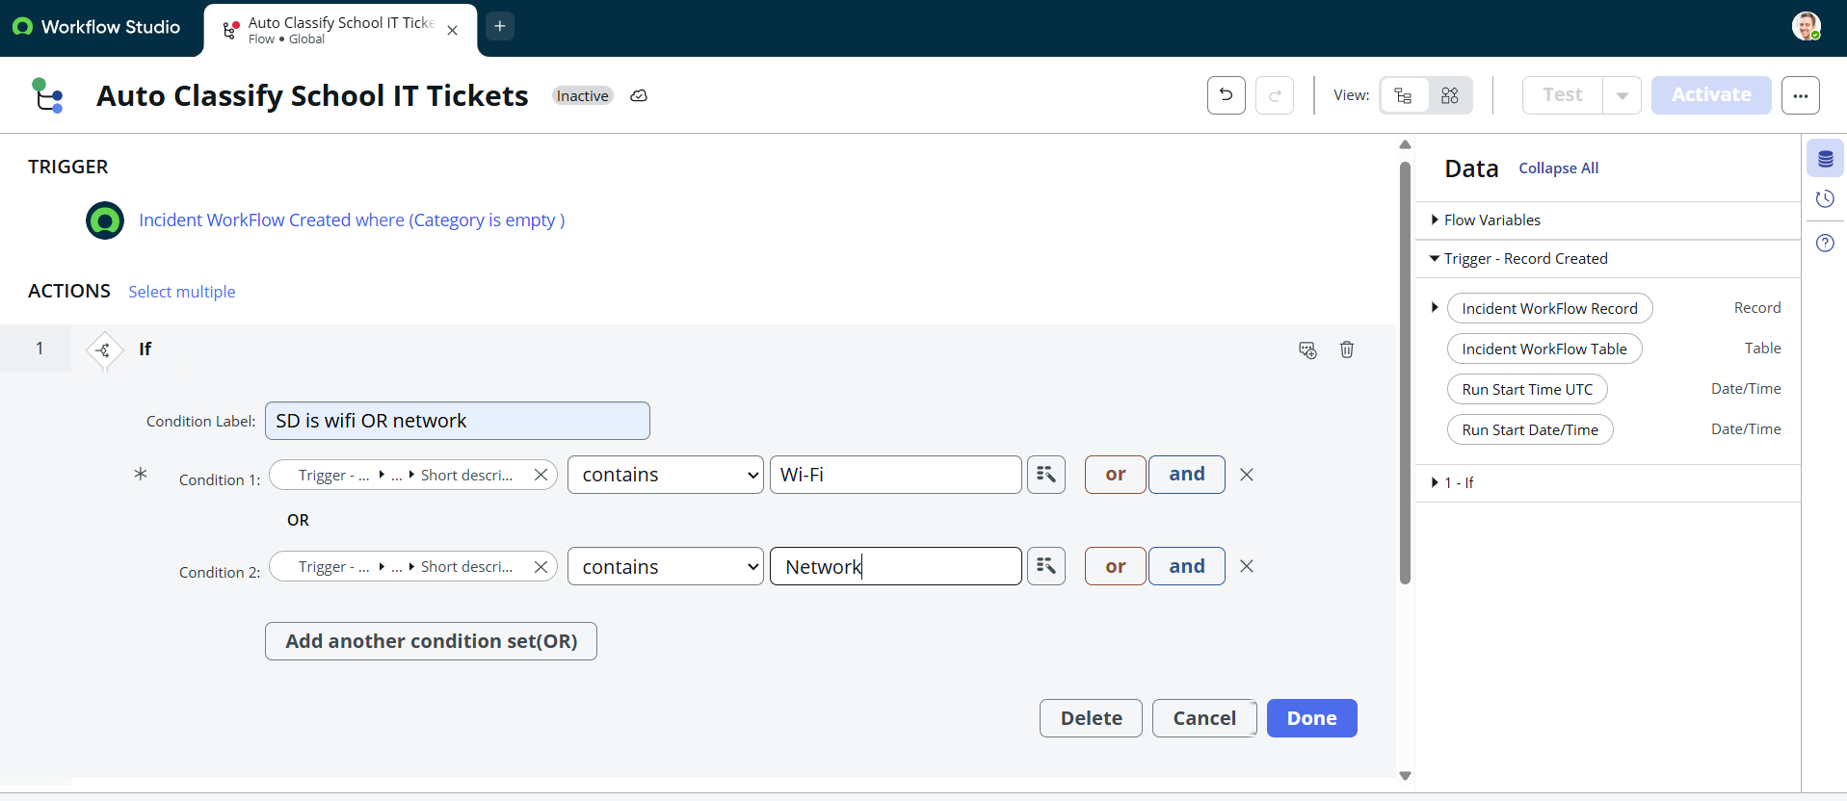
2. | Accuracy | Training Accuracy - Not Applicable  Validation Accuracy - Not Applicable  Testing Result - WiFi ticket classified as Network → WiFi; Projector ticket classified as Hardware → Projector. | 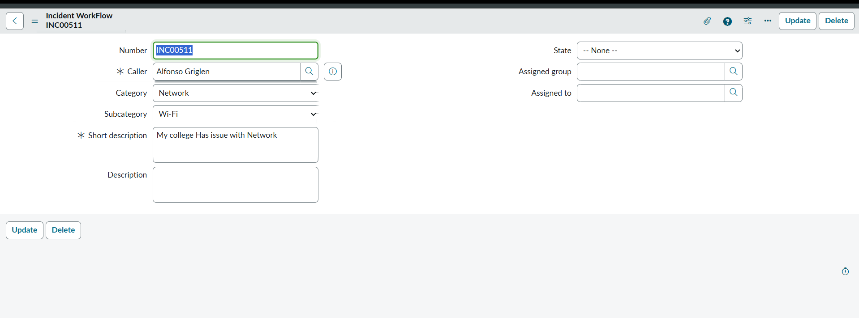  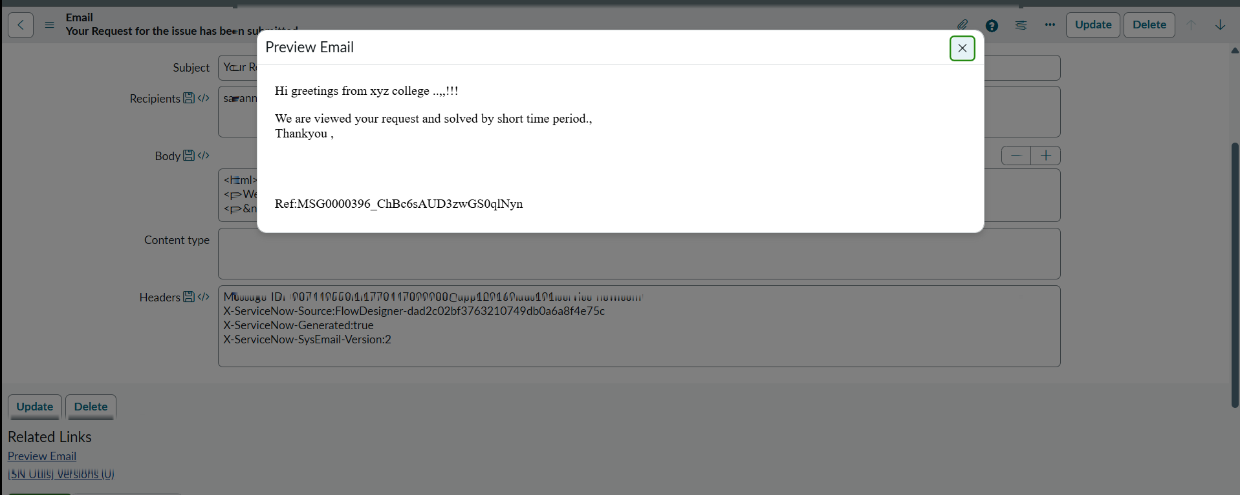
3. | Fine Tunning Result( if Done) | Not Applicable - No fine tuning was performed. The project uses Flow Designer automation with keyword-based classification.

